SET 28: VEHICLE PERFORMANCE ANALYSIS
Course: DSA0601 – Data Handling and Visualization
Experiment: Data Visualization using R
AIM
To analyze vehicle performance using violin plots, scatter plots, correlation heatmaps, and an interactive Tableau dashboard.
DATASET: VEHICLE PERFORMANCE
Vehicle ID | Engine Size (L) | Horsepower | Fuel Efficiency (km/l) | Top Speed (km/h) | Safety Rating
V1 | 1.5 | 110 | 18 | 180 | 4
V2 | 2.0 | 150 | 15 | 200 | 5
V3 | 3.0 | 250 | 12 | 250 | 5
V4 | 2.5 | 200 | 14 | 220 | 4
V5 | 1.8 | 130 | 17 | 190 | 3
PROGRAM 1: VIOLIN PLOT OF FUEL EFFICIENCY BY SAFETY RATING
Aim: To compare fuel efficiency across different safety-rating categories using a violin plot.
R Program:
install.packages("vioplot")
library(vioplot)
rating<-c(4,5,5,4,3)
fuel<-c(18,15,12,14,17)
boxplot(fuel~rating,col="lightblue",
main="Fuel Efficiency by Safety Rating",
xlab="Safety Rating",ylab="Fuel Efficiency (km/l)")
vioplot(fuel[rating==3],fuel[rating==4],
fuel[rating==5],names=c("3","4","5"),
col=c("pink","lightgreen","skyblue"),
main="Fuel Efficiency by Safety Rating",
xlab="Safety Rating",ylab="Fuel Efficiency (km/l)")
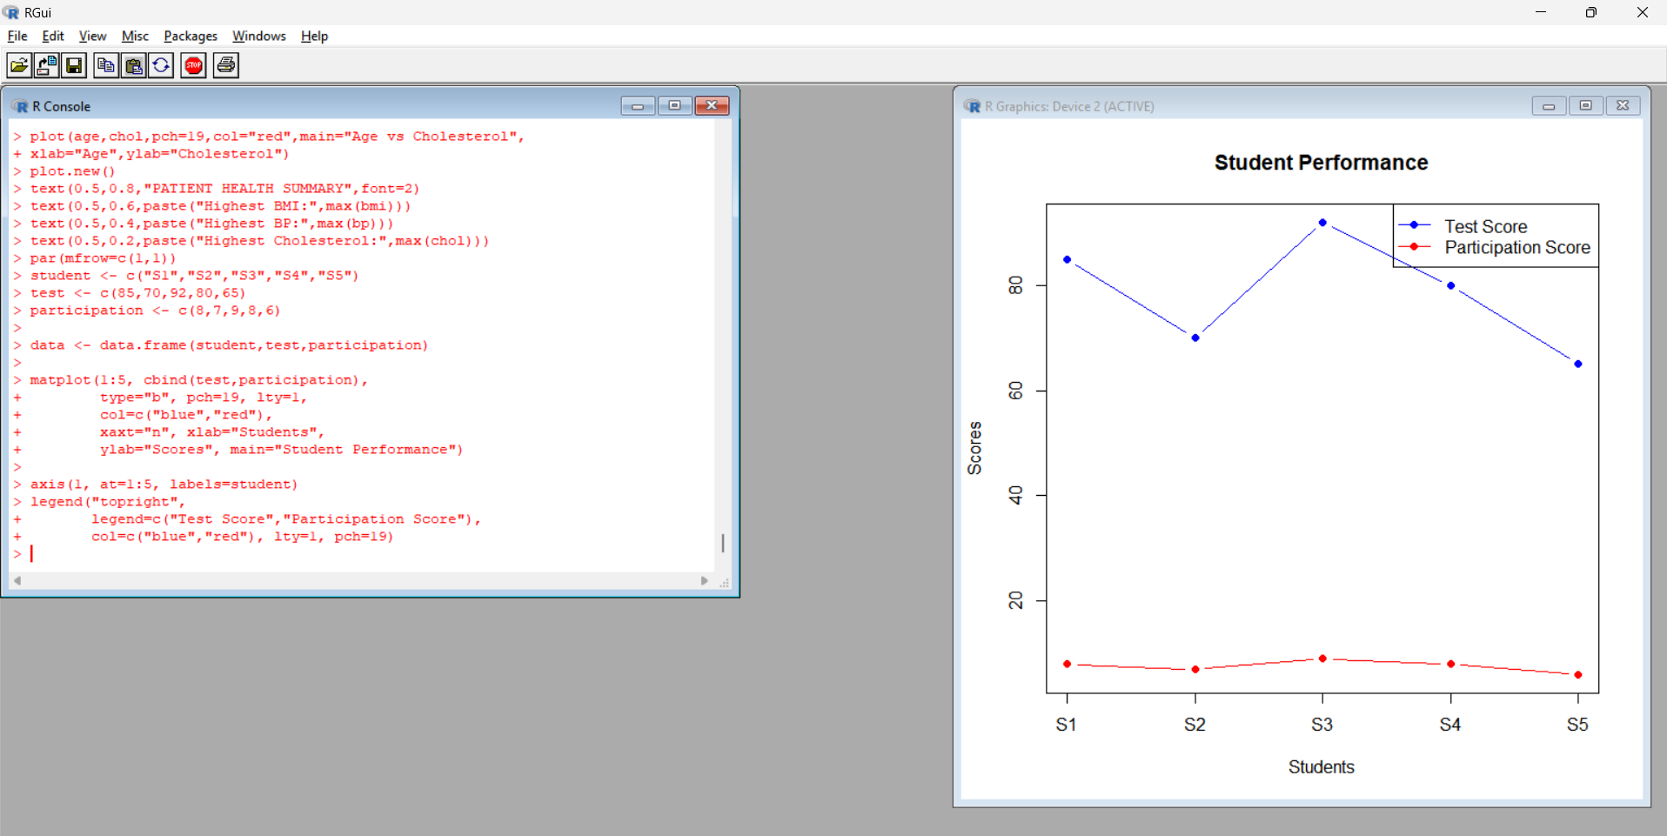
Procedure:
- Enter the safety ratings and fuel-efficiency values.
- Install and load the vioplot package.
- Group fuel-efficiency values by safety rating.
- Generate the violin plot and compare the groups.
Output: Violin plot comparing fuel efficiency across safety ratings.
Observation: The vehicles with safety rating 3, 4, and 5 have fuel efficiencies of 17, 18 and 15, 14 and 12 km/l, respectively. The small dataset limits conclusions about the distributions and variability within each group.
PROGRAM 2: HORSEPOWER VS TOP SPEED
Aim: To examine the relationship between horsepower and top speed, using engine size to differentiate points by color.
R Program:
engine<-c(1.5,2.0,3.0,2.5,1.8)
hp<-c(110,150,250,200,130)
speed<-c(180,200,250,220,190)
plot(hp,speed,pch=19,
col=heat.colors(5),
main="Horsepower vs Top Speed",
xlab="Horsepower",ylab="Top Speed (km/h)")
text(hp,speed,labels=paste(engine,"L"),pos=3)
abline(lm(speed~hp),col="blue",lwd=2)
print(cor(hp,speed))
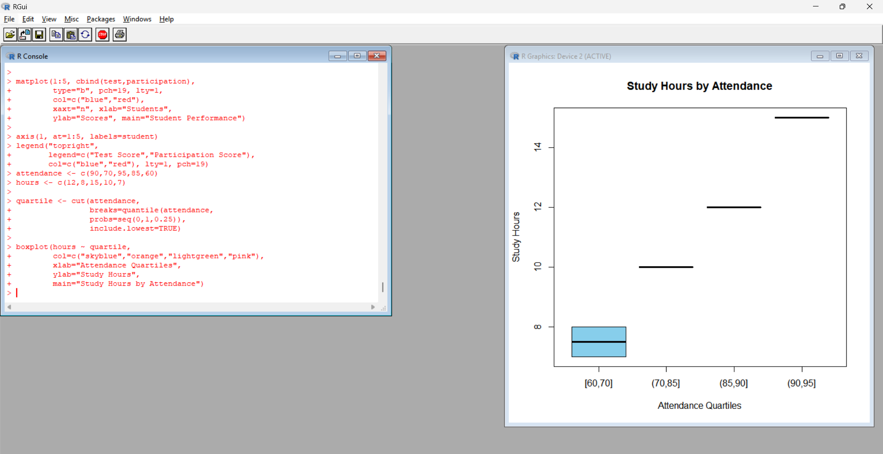
Procedure:
- Store engine size, horsepower, and top speed in vectors.
- Create a scatter plot of horsepower against top speed.
- Label each point with its engine size.
- Add a regression line and calculate the correlation coefficient.
Output: Scatter plot showing the relationship between horsepower and top speed.
Observation: Horsepower and top speed have a strong positive correlation in the given dataset. Vehicles with higher horsepower generally have higher top speeds. The correlation is approximately 0.98.
PROGRAM 3: CORRELATION HEATMAP
Aim: To create a correlation heatmap for all numerical variables and identify variables strongly associated with top speed.
R Program:
data<-data.frame(
Engine_Size=c(1.5,2.0,3.0,2.5,1.8),
Horsepower=c(110,150,250,200,130),
Fuel_Efficiency=c(18,15,12,14,17),
Top_Speed=c(180,200,250,220,190),
Safety_Rating=c(4,5,5,4,3))
corr<-cor(data)
print(round(corr,2))
heatmap(corr,Rowv=NA,Colv=NA,
col=colorRampPalette(c("blue","white","red"))(100),
scale="none",main="Vehicle Performance Correlation Heatmap")
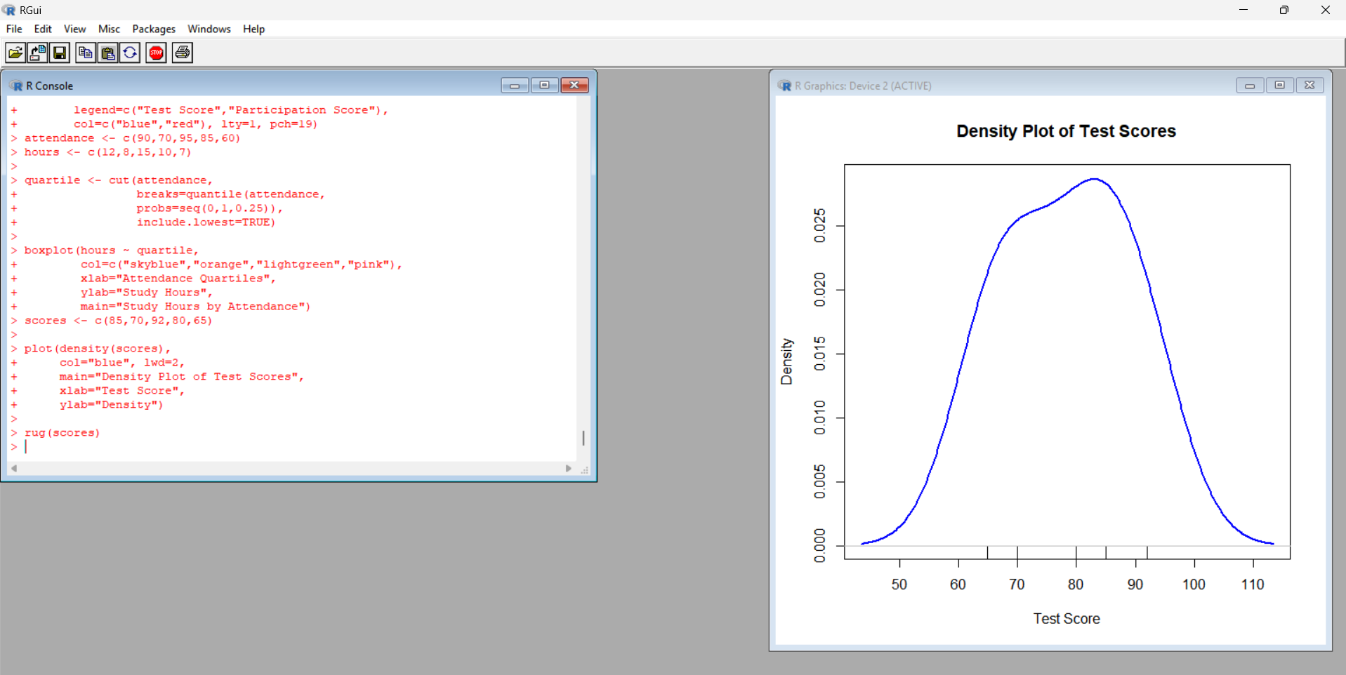
Procedure:
- Create a data frame containing all numerical variables.
- Calculate the correlation matrix using cor().
- Display the correlation values rounded to two decimal places.
- Use heatmap() to visualize positive and negative relationships.
Output: Correlation matrix and heatmap of vehicle performance variables.
Observation: Horsepower has a strong positive relationship with top speed. Engine size also has a strong positive relationship with top speed in this dataset. Fuel efficiency tends to decrease as horsepower and top speed increase. These are associations and do not prove causation.
PROGRAM 4: INTERACTIVE TABLEAU DASHBOARD
Aim: To develop an interactive dashboard combining bar charts and scatter plots with filters for engine size and safety rating.
Procedure:
- Enter the dataset in Excel and save it as Vehicle_Performance.xlsx.
- Open Tableau and connect to the Excel file.
- Create a bar chart with Vehicle ID on Columns and Fuel Efficiency on Rows.
- Create a scatter plot with Horsepower on Columns and Top Speed on Rows.
- Drag Safety Rating to Color and Engine Size to Detail.
- Add Engine Size and Safety Rating as filters.
- Create another bar chart comparing fuel efficiency and top speed by vehicle.
- Create a new dashboard and combine the charts.
- Add the filters to the dashboard and select Apply to Worksheets → All Using This Data Source.
- Set the dashboard title as Vehicle Performance Analysis Dashboard.
Output: Interactive Tableau dashboard showing vehicle efficiency, horsepower, top speed, and safety ratings.
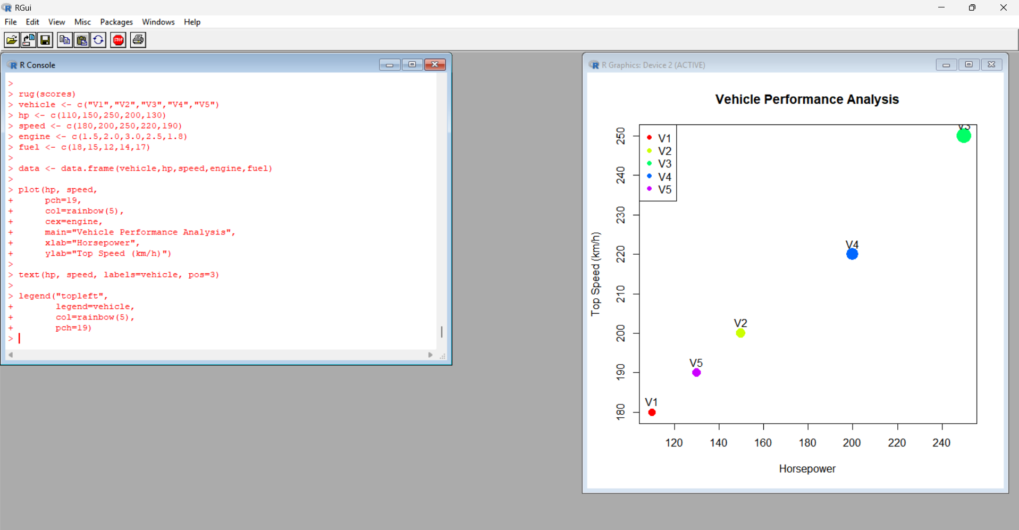
Observation: The dashboard allows users to compare vehicles based on fuel efficiency and performance. V3 has the highest horsepower (250) and top speed (250 km/h), but the lowest fuel efficiency (12 km/l). V2 and V3 have the highest safety rating of 5.
RESULT
Vehicle performance was analyzed using a violin plot, scatter plot, correlation heatmap, and interactive Tableau dashboard. The analysis showed a strong positive relationship between horsepower and top speed, while higher-performance vehicles generally showed lower fuel efficiency in the supplied dataset.

